**Lab 7- TIME PROJECT MANAGEMENT**

1. **Given below is a Table WBS of RAMOV Project.**

**Based on your proposed AIProject, draw your Gantt chart with your timeline, milestone and description as given example at the Figure 1.**

* **The Gantt charts should provide a standard format for displaying project schedule information by listing project activities and their corresponding start and finish dates in a calendar format.**

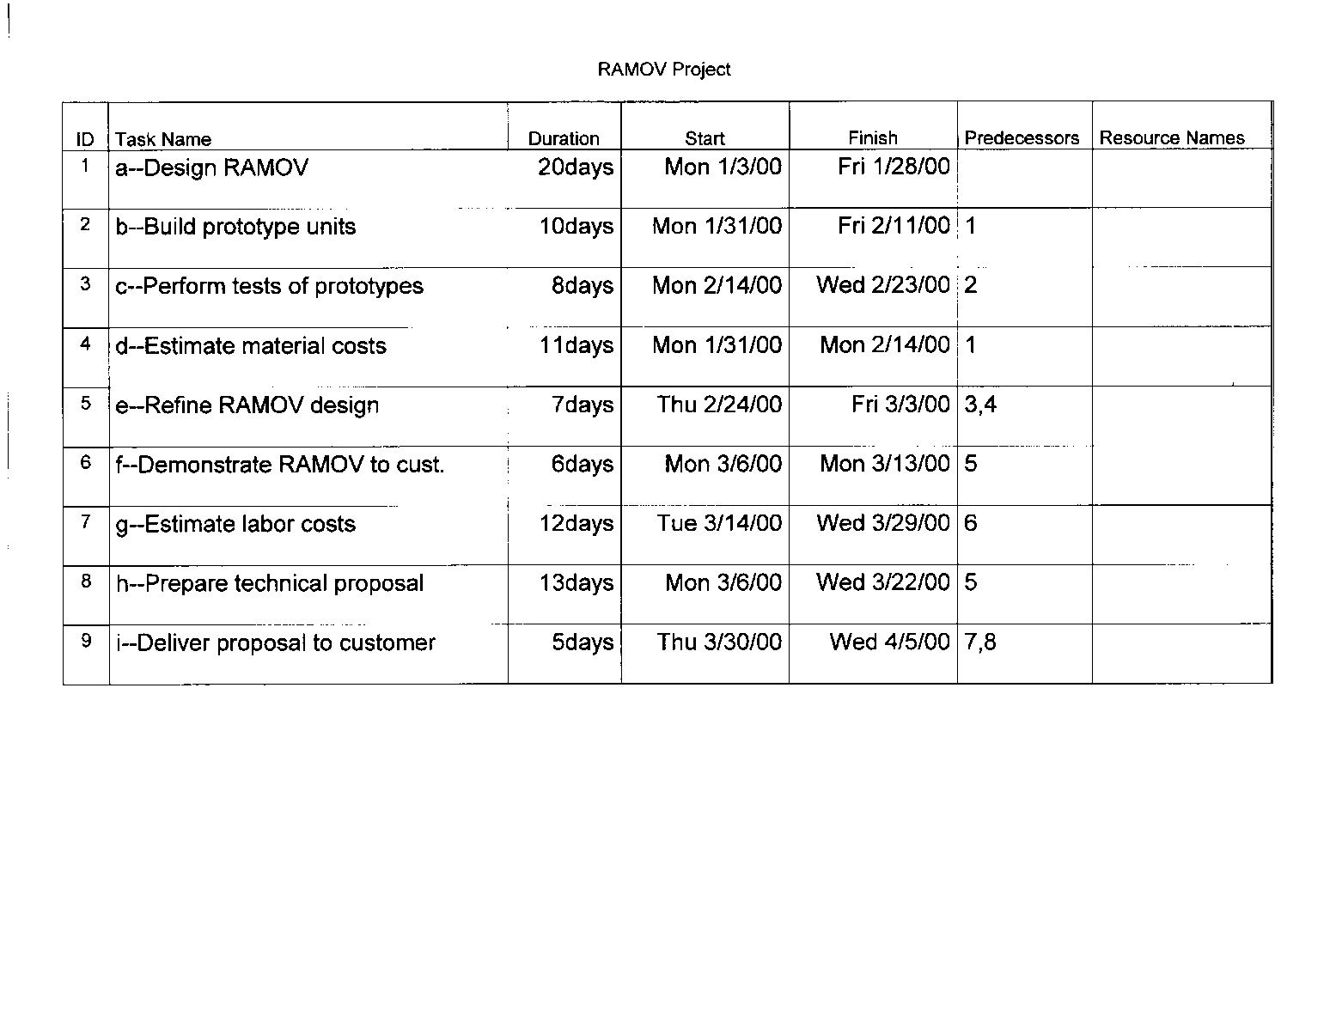

**Figure 1: RAMOV Project**

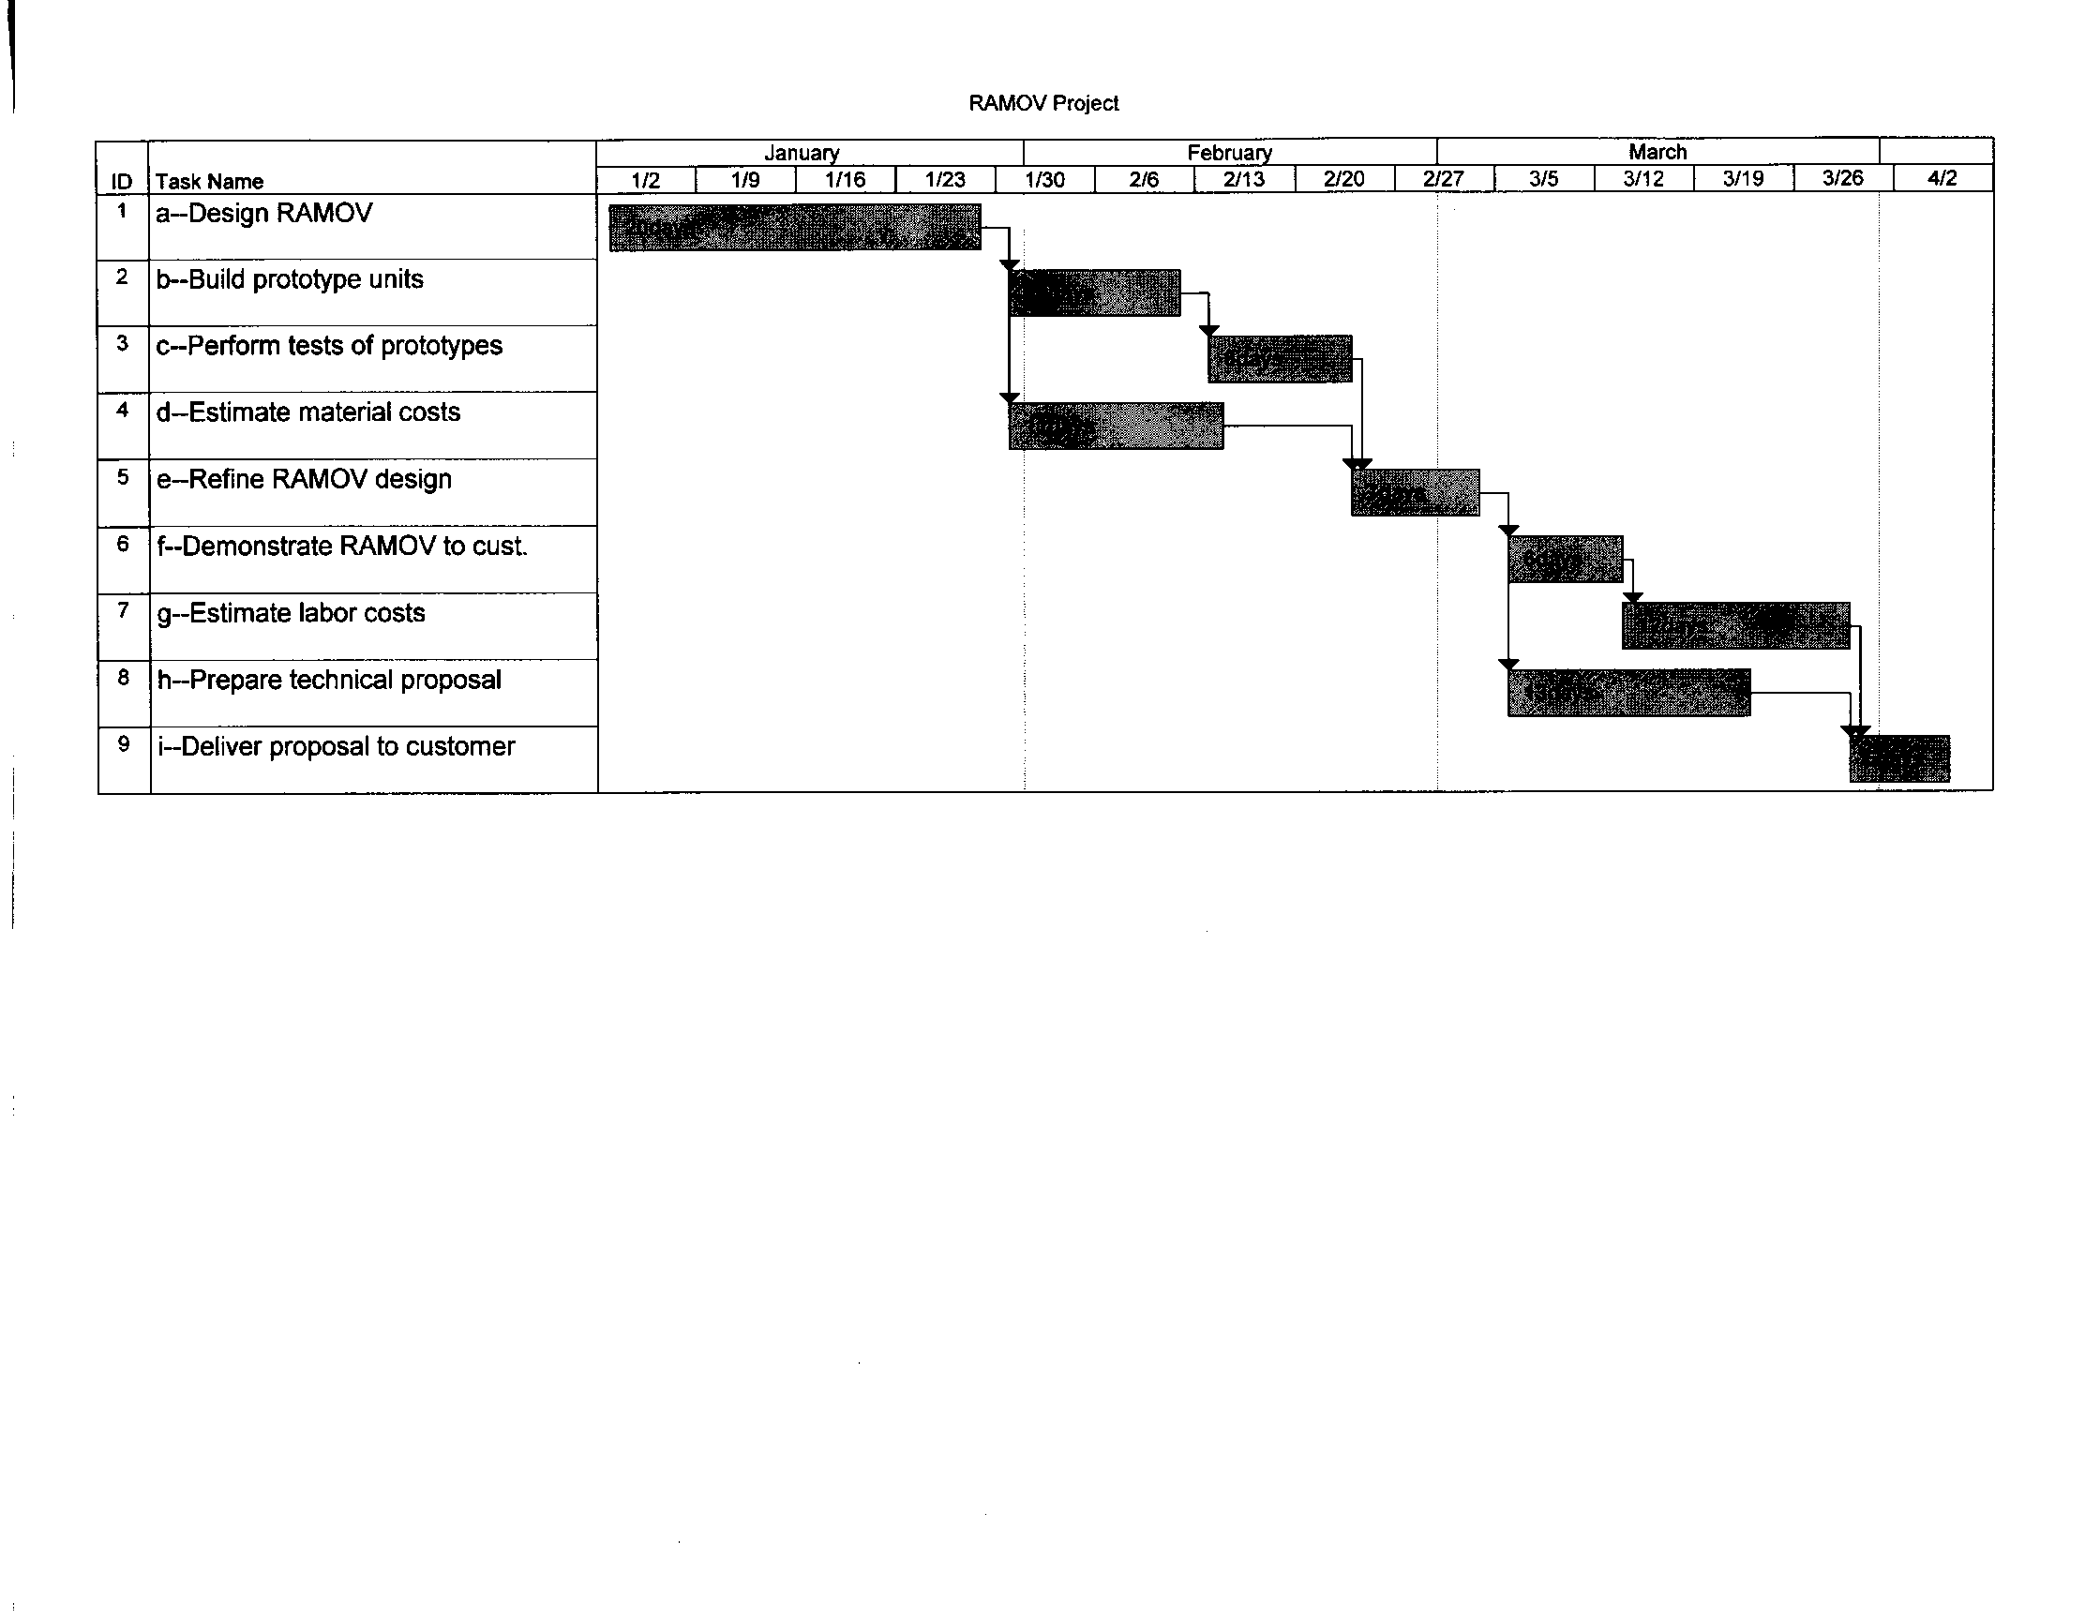**Sample Gantt Chart**

**Using Time Management Gantt Chart provide, build your AI Project Gatt Chat with your timeline, milestone and description.**